Name: Mohau Menyatsoe

Student number: St10335992

Module: CLDV 6212

Assessment: POE Part 1

Table Storage:

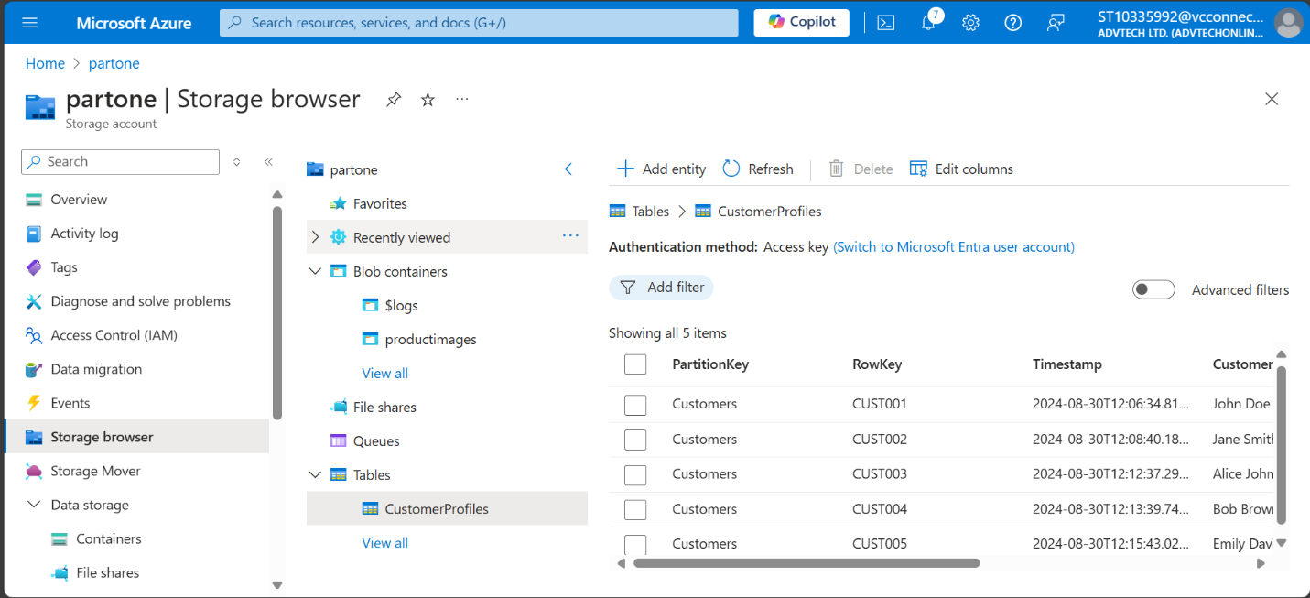

Blob Storage:

Queues Storage:

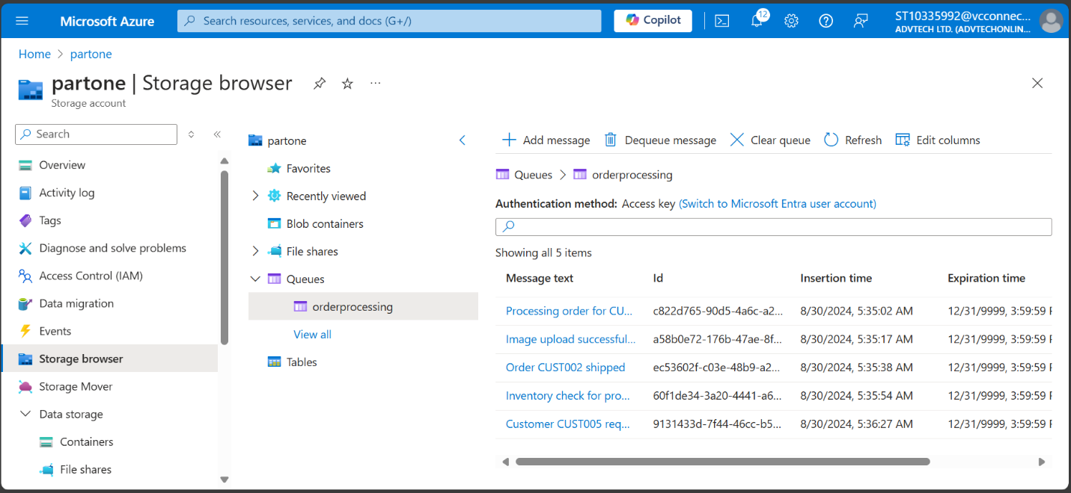

File Share:

Deployment: (couldn’t create an app service. Multiple attempts)

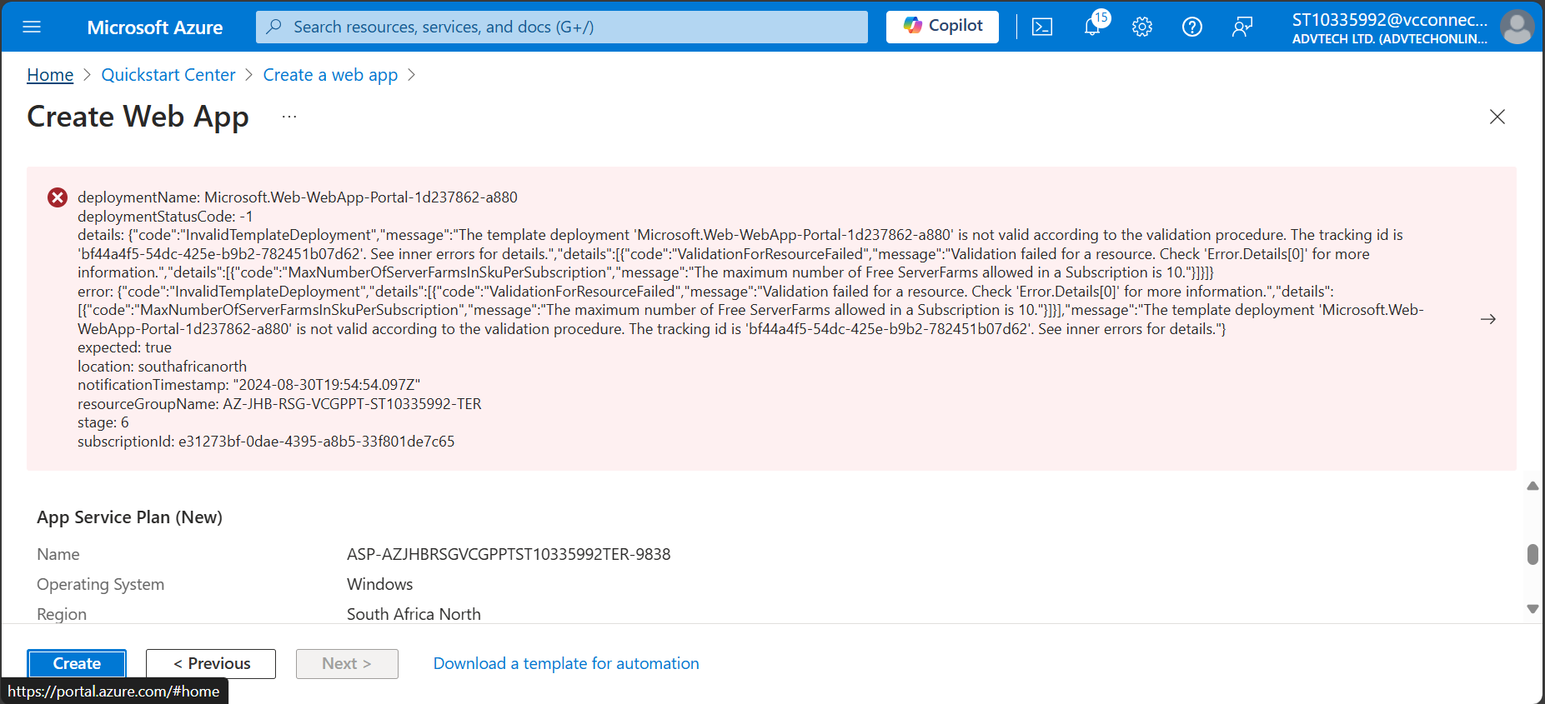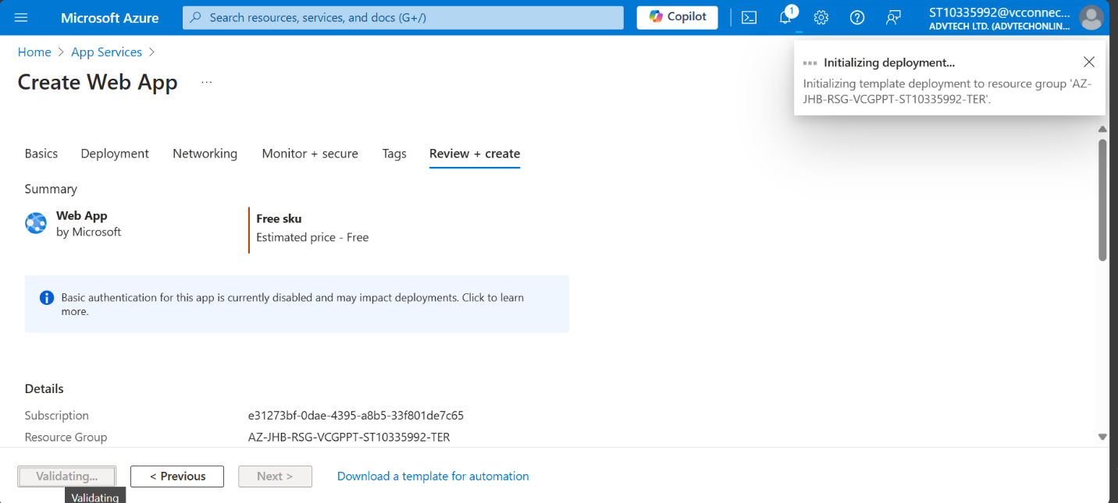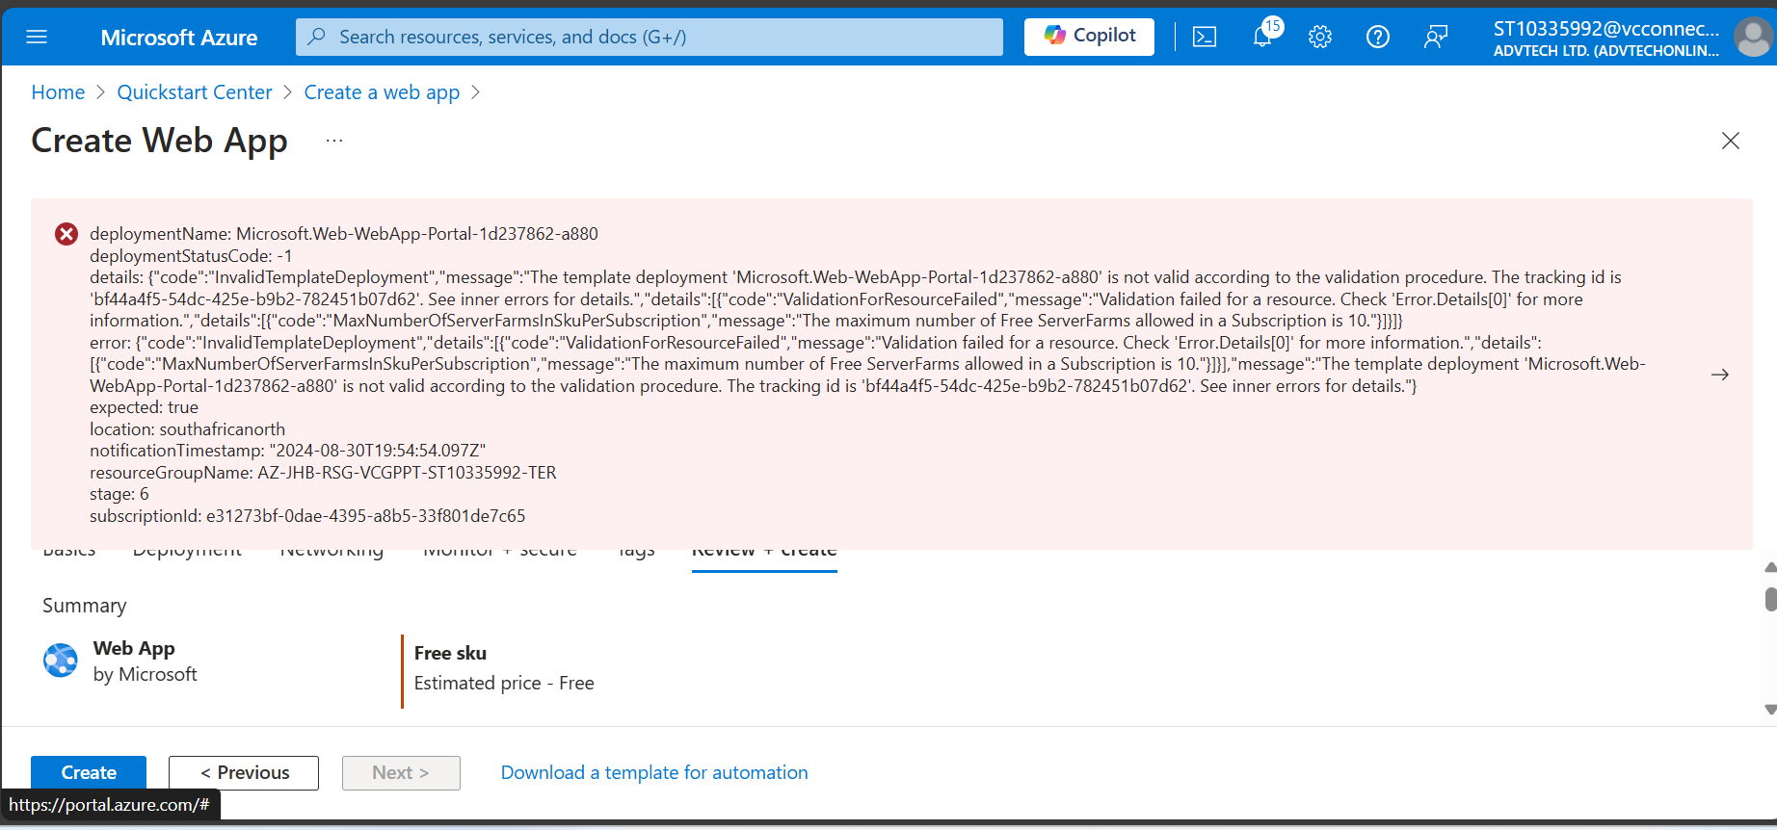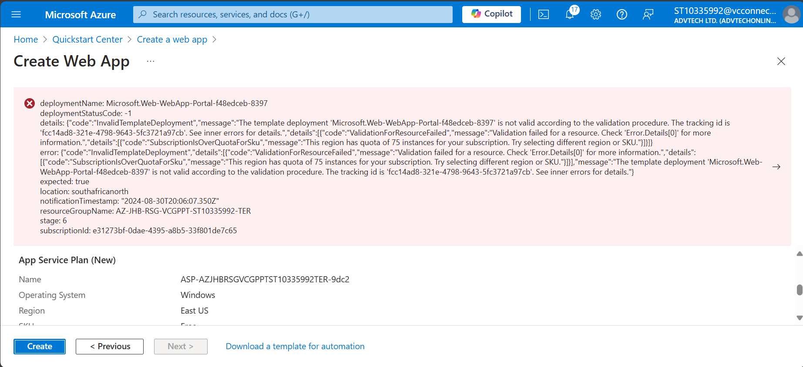(Benjamin Day, 2023)

My Website:

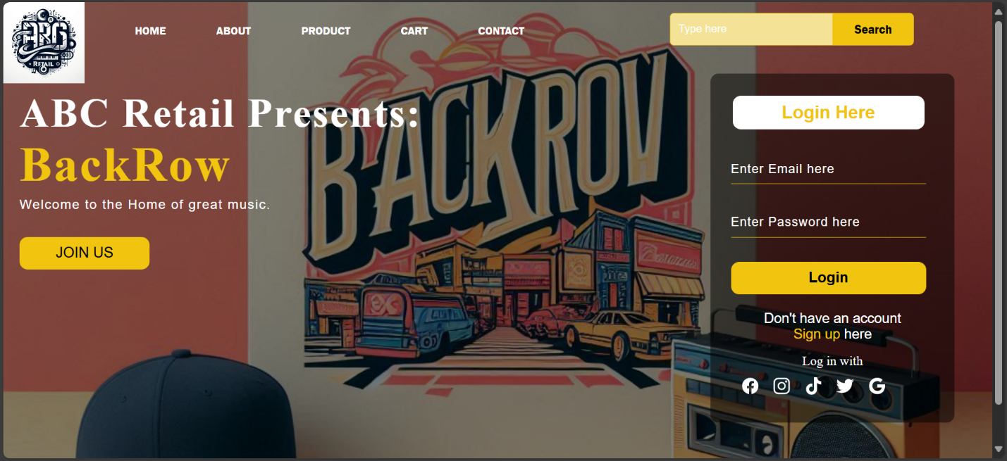(Online Tutorials, 2020)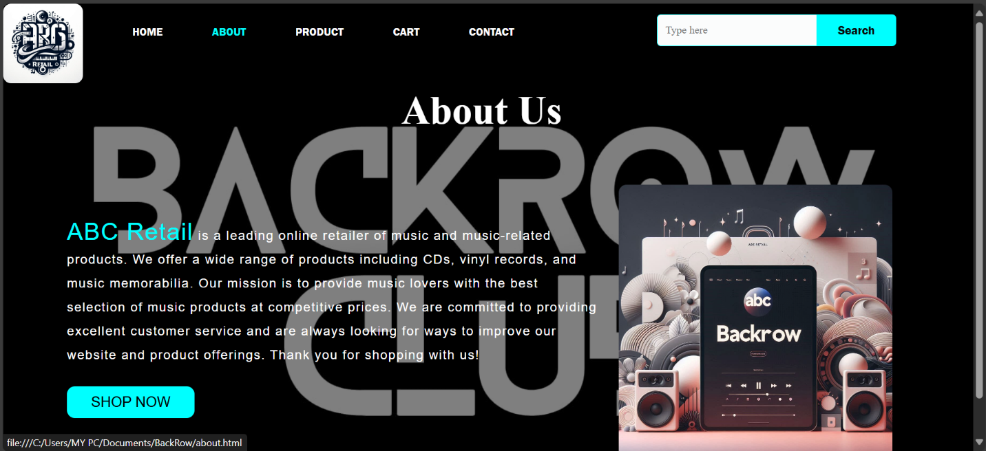 (Learn Web, 2023)

References:

Learn Web (2023). *How To Create Responsive Animated About Us Page In HTML and CSS: Website Design Tutorial*. [online] YouTube. Available at: https://www.youtube.com/watch?v=jI-hFANig-w [Accessed 30 Aug. 2024].

‌

Benjamin Day (2023). *Demo: Deploy an Azure App Service using Visual Studio Code*. [online] YouTube. Available at: https://www.youtube.com/watch?v=UcROU2kO4j0 [Accessed 30 Aug. 2024].

Online Tutorials (2020). *Responsive Contact Us Page Design using Html CSS | HTML Responsive Web Page Design*. *YouTube*. Available at: https://www.youtube.com/watch?v=gggB0Nq5vBk.